FlightReservationScenario_TestForBookTicketsWithValidCreditCard_Instance1_08-Jun-2017_12-47-36_PM_Enter_user_credentials.pn

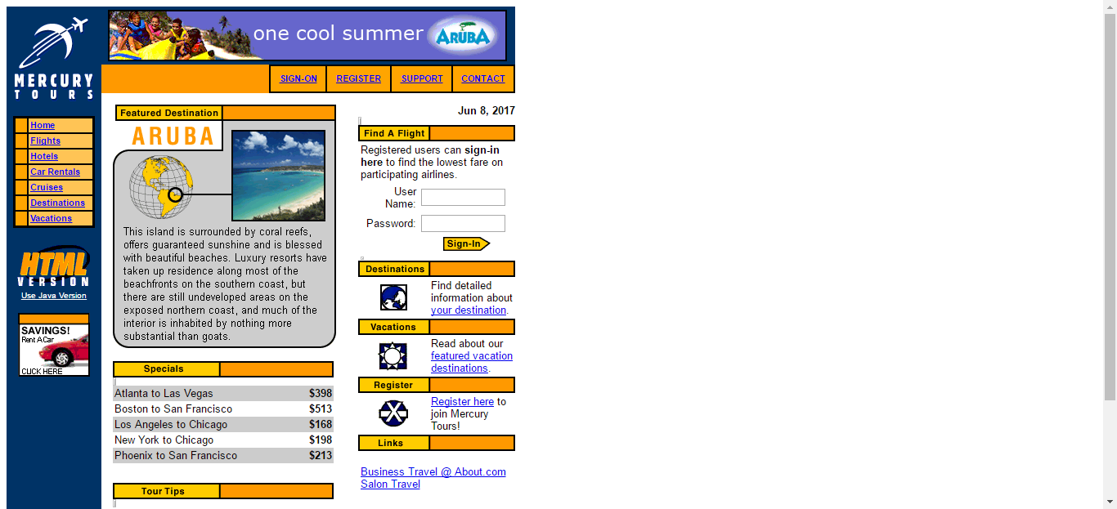

FlightReservationScenario_TestForBookTicketsWithValidCreditCard_Instance1_08-Jun-2017_12-47-36_PM_Login.png

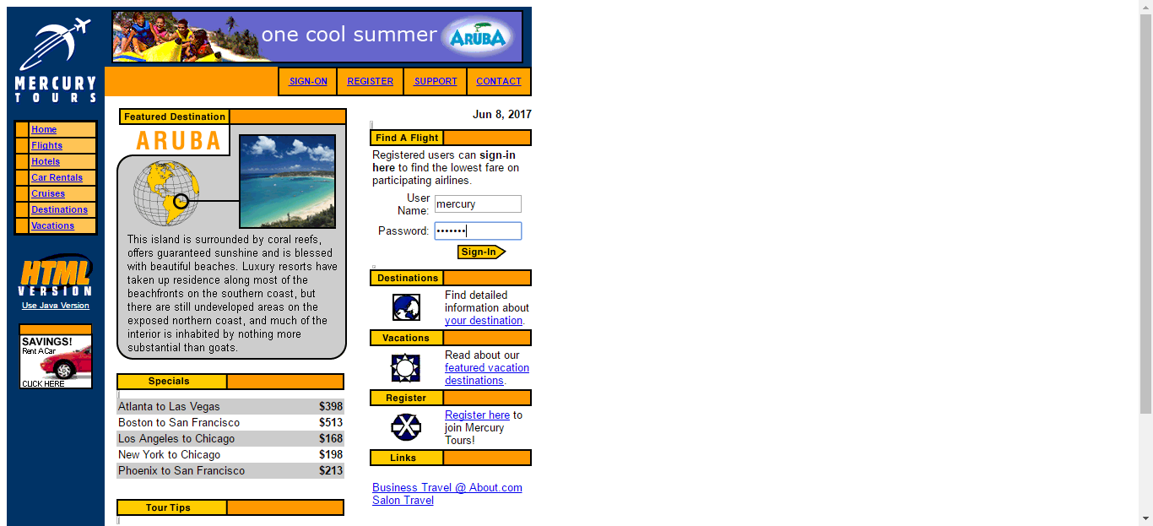

FlightReservationScenario_TestForBookTicketsWithValidCreditCard_Instance1_08-Jun-2017_12-47-40_PM_Find_Flights.png

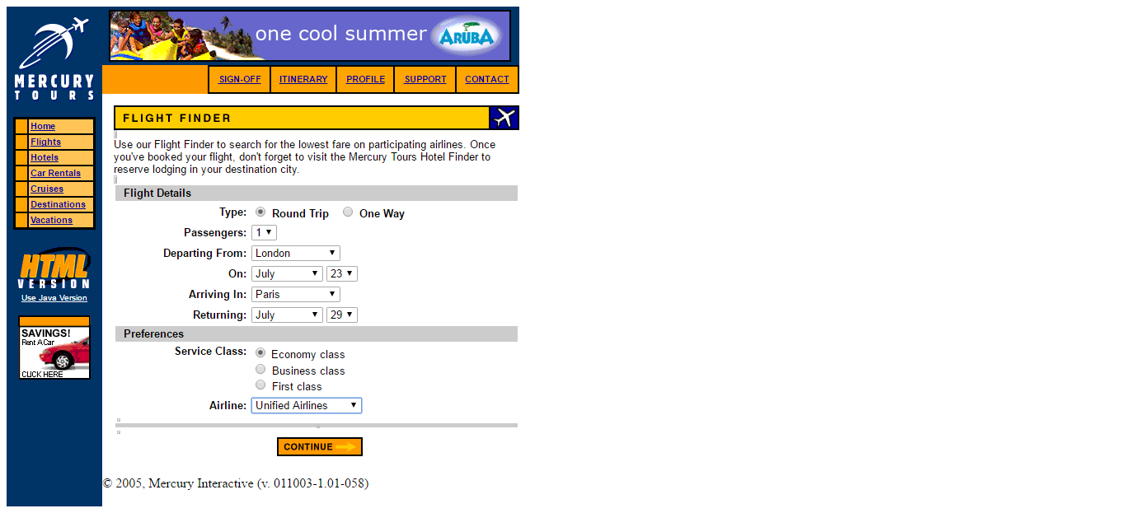

FlightReservationScenario_TestForBookTicketsWithValidCreditCard_Instance1_08-Jun-2017_12-47-44_PM_Book_Tickets.png

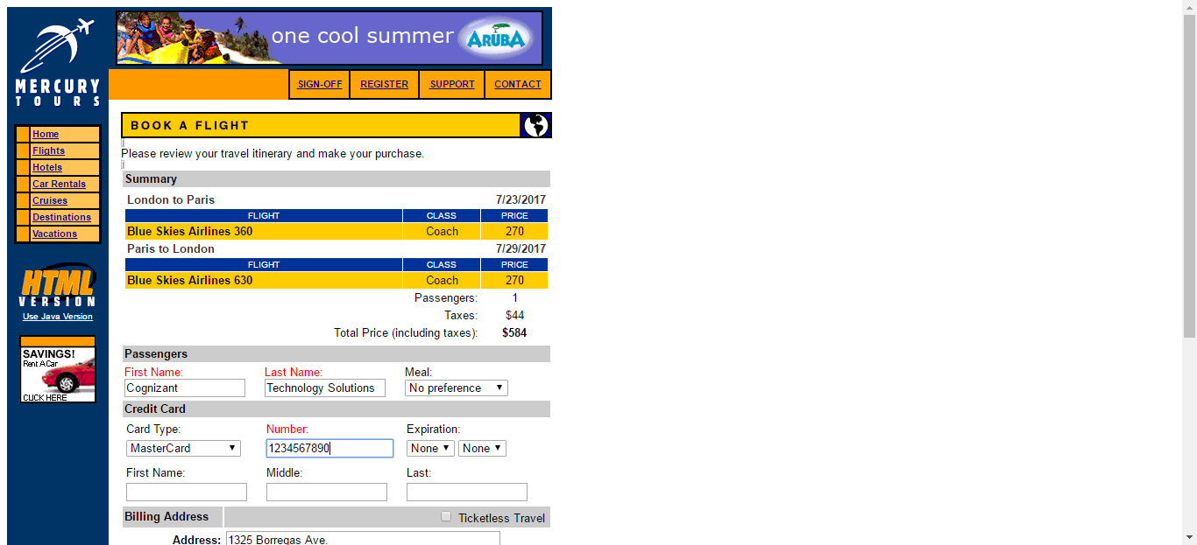

FlightReservationScenario_TestForBookTicketsWithValidCreditCard_Instance1_08-Jun-2017_12-47-47_PM_Flight_Confirmation.png

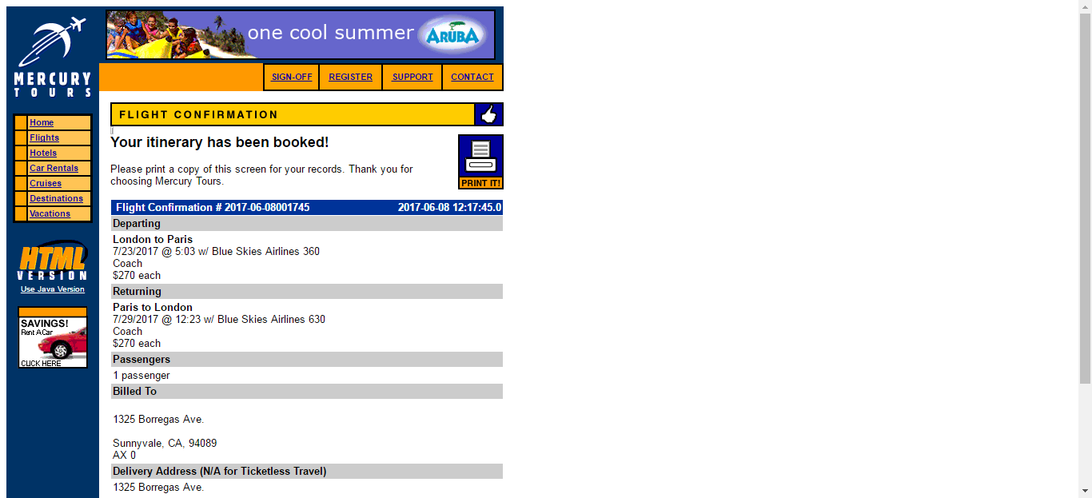

FlightReservationScenario_TestForBookTicketsWithValidCreditCard_Instance1_08-Jun-2017_12-47-47_PM_Verify_Booking.png



FlightReservationScenario_TestForBookTicketsWithValidCreditCard_Instance1_08-Jun-2017_12-47-49_PM_Find_Flights.png

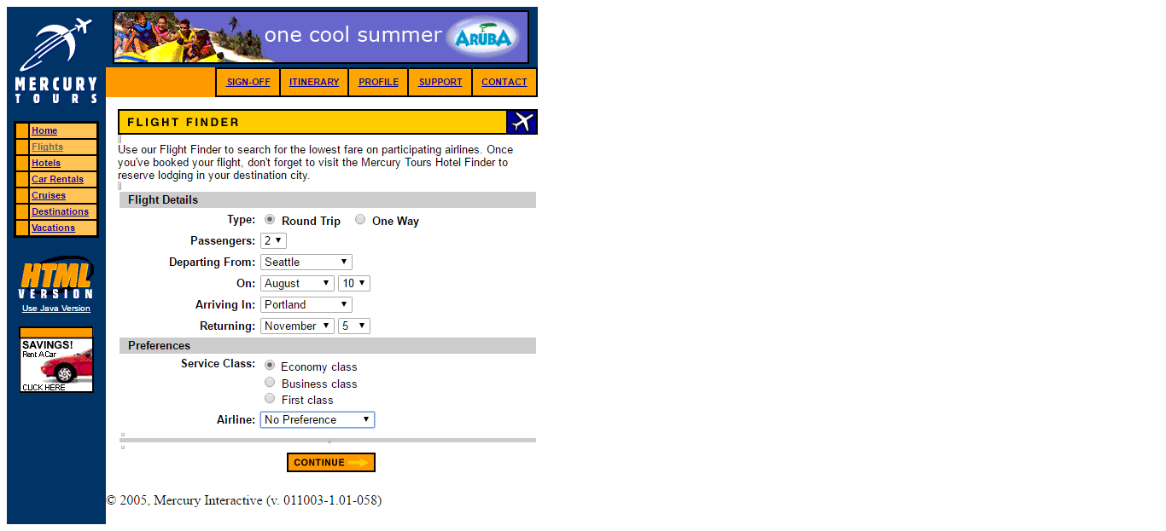

FlightReservationScenario_TestForBookTicketsWithValidCreditCard_Instance1_08-Jun-2017_12-47-52_PM_Book_Tickets.png

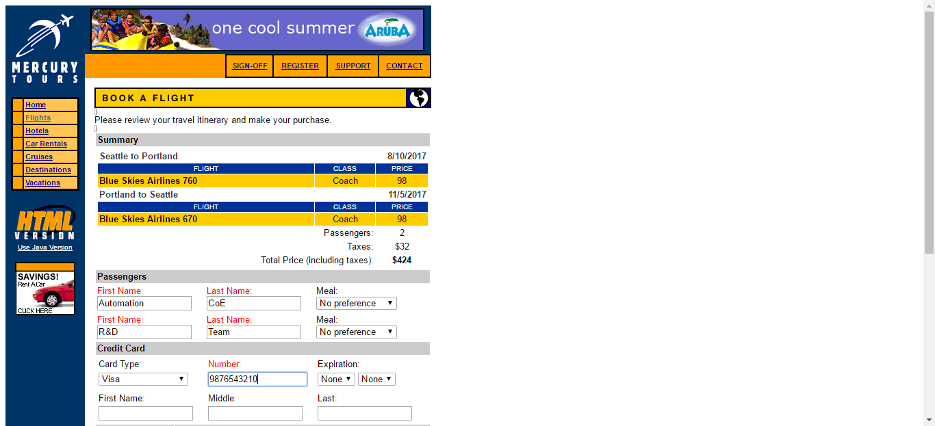

FlightReservationScenario_TestForBookTicketsWithValidCreditCard_Instance1_08-Jun-2017_12-47-53_PM_Verify_Booking.png

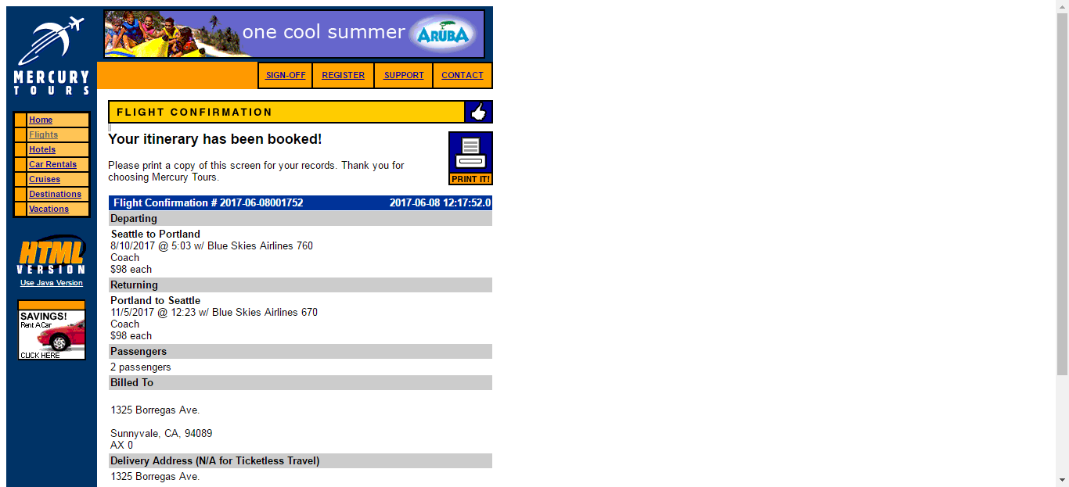

FlightReservationScenario_TestForBookTicketsWithValidCreditCard_Instance1_08-Jun-2017_12-47-54_PM_Flight_Confirmation.png

